**DATA VISUALIZATION PROJECT REPORT**

**(**Project Semester August-December 2024)

***Mapping the Future of Mobility: EV Charging Patterns and***

***Usage Trends***

Submitted by

Name: Chundru Rishith Sai Chowdary

Registration number: 12212330

Programme: B.Tech. (Computer Science and Engineering)

Section: K22BW

Course Code: INT233

Under the Guidance of

**Name: Vikas Mangotra**

**U.ID: 31488**

**Discipline of CSE/IT**

**Lovely School of Computer Science and Engineering**

**Lovely Professional University, Phagwara**

**DECLARATION**

I, **Chundru Rishith Sai Chowdary**, student of **B.Tech** under CSE/IT Discipline, at Lovely Professional University, Punjab. I hereby declare that all the information furnished in this project report is based on my own intensive work and is genuine.

Date: 15-11-2024 Signature

Registration No: 12212330 Chundru Rishith Sai Chowdary

**CERTIFICATE**

This is to certify that **Chundru Rishith Sai Chowdary** bearing Registration no. **12212330** has completed **INT233** project titled, **“Mapping the Future of Mobility: EV Charging Patterns and Usage Trends”** under my guidance and supervision. To the best of my knowledge, the present work is the result of his/her original development, effort and study.

**Vikas Mangotra**

**School of Computer Science and Engineering**

Lovely Professional University

Phagwara, Punjab.

Date: 14-11-2024

**ACKNOWLEDGMENT**

I would like to extend my gratitude to Vikas Mangotra Sir, for their guidance, support, and encouragement throughout this project. This report is the result of collaborative efforts and insights gained from my faculty member.

**TABLE OF CONTENTS**

1. **INTRODUCTION**
2. **SCOPE OF ANALYSIS**
3. **OBJECTIVES**
4. **METHODOLOGY**
5. **EXISTING SYSTEM**
6. **SOURCE OF DATASET**
7. **ETL PROCESS**
8. **ANALYSIS ON DATASET**
9. **DASHBOARD**
10. **LIST OF ANALYSIS WITH RESULTS**
11. **FUTURE SCOPE**
12. **CONCLUSION**
13. **REFERENCES**
14. **BIBLIOGRAPHY**

**INTRODUCTION**

In recent years, electric vehicles (EVs) have grown in popularity as more people and companies seek sustainable alternatives to traditional gas-powered cars. EVs offer several advantages, such as lower emissions, reduced fuel costs, and quieter operation. However, as EV use has increased, so has the need for effective charging infrastructure to support these vehicles on the road. EV charging stations are essential in helping drivers maintain their vehicles’ battery levels during daily use, long journeys, and especially in areas with fewer residential charging options.

This project analyses patterns in EV charging behaviour to gain insight into how, when, and where drivers are charging their vehicles. By understanding these patterns, we can learn more about peak times for charging, the costs involved, and how different factors like temperature and vehicle type influence charging needs. This data is valuable for a wide range of stakeholders, including city planners, EV manufacturers, and charging station operators. For instance, cities can use this information to identify areas where more charging stations might be needed, and manufacturers can use it to improve battery life and charging speed.

Using a dataset that records details like charging station ID, charging times, costs, energy consumed, and user demographics, this project aims to uncover patterns that reveal how charging habits vary by location, vehicle model, weather, and more. The results will help paint a clearer picture of the current EV charging landscape and suggest ways to make charging more accessible, efficient, and cost-effective for everyone.

The analysis was conducted in Tableau, a powerful visualization tool, to create clear and interactive dashboards that highlight key insights. This project will guide future decisions in building a sustainable charging network that supports the growing number of EVs on the road.

**SCOPE OF ANALYSIS**

The scope of this project is to analyse diverse factors that impact electric vehicle (EV) charging patterns, aiming to uncover insights that can support efficient infrastructure planning and enhance user experience. This analysis covers several dimensions of EV charging behaviour including:

1. **Charging Time and Duration**: By examining when drivers charge their vehicles and how long each session lasts, we can identify peak charging hours and determine the demand on charging infrastructure throughout the day. This helps in understanding if existing stations meet user needs or if more stations are required during peak hours.
2. **Energy Consumption and Charging Cost**: Investigating the relationship between energy consumed and associated costs helps identify trends in charging expenses. This data could also reveal if certain times or conditions result in higher costs, providing opportunities for users to save on charging and for providers to manage pricing models effectively.
3. **Environmental Factors**: The impact of external conditions, such as temperature, on charging efficiency and battery performance is analysed to determine how weather variations affect EV charging needs. This understanding can inform station design in diverse climates and help anticipate seasonal demand changes.
4. **Geographic Distribution and Location Insights**: Analysing charging station locations provides insights into which areas experience the most activity, helping to identify potential EV charging deserts or oversaturated areas. This spatial analysis is crucial for making data-driven decisions in expanding the EV charging network where it is most needed.
5. **Technology and Charger Types**: Examining the usage of various charger types (e.g., fast chargers vs. standard chargers) helps understand user preferences and the demand for quicker charging solutions. Insights here can guide providers on where to install faster chargers to better serve high-demand locations.

This analysis aims to serve EV manufacturers, city planners, energy providers, and policy makers by providing actionable insights into optimizing the EV charging network for a growing user base.

**OBJECTIVES**

The objective of the first visualization is to display the total energy consumed by each vehicle model in a clear, sequential manner using a waterfall chart. This method highlights the cumulative effect of each vehicle's energy consumption, emphasizing both positive and negative changes in the dataset, and makes it easier to compare the overall energy usage across different vehicle models. The second visualization compares the relationship between the average distance driven and the average charging rate for each vehicle model, helping to visualize trends or correlations between distance and charging efficiency. The third visualization visually represents the geographic distribution of energy consumption by electric vehicles at various charging station locations, identifying regional patterns in energy usage and offering insights into areas with higher or lower energy demand for charging. The fourth visualization presents a focused view of specific measures from the dataset, selecting and filtering particular measures to provide clarity on the most relevant metrics for decision-making. The fifth visualization shows the trend of average charging costs across different charging station locations, offering valuable insights for users and station operators regarding pricing strategies and cost trends. The sixth visualization compares total charging duration and charging rate for each charging station location, using a dual-bar format with a calculated midpoint to highlight differences between the two measures and offering a visual comparison of charging efficiency versus time.

The seventh visualization displays the proportion of total distance driven by each vehicle model using a pie chart, emphasizing each model's contribution to the overall distance driven. This makes it easier to compare vehicle usage across models. The eighth visualization shows the average vehicle age for each vehicle model, providing insights into fleet composition, usage, and potential maintenance needs. The ninth visualization visualizes the total charging cost for each vehicle model using a funnel chart, highlighting how charging costs fluctuate across different models. By using a negative sum for one of the values, it illustrates cost efficiency and changes in overall charging costs. The tenth visualization compares the charging start and end percentages for each vehicle model, allowing both measures to be visualized on the same chart. This demonstrates how the two percentages vary together, offering insights into charging behaviour and efficiency for different vehicle models.

The eleventh visualization aims to display the average battery capacity for each vehicle model, highlighting trends in battery capacity across models. This chart offers a clear representation of how battery capacity differs among vehicle models, providing valuable insights into charging requirements and efficiency. Together, these visualizations present a comprehensive analysis of electric vehicle data, helping to better understand key metrics such as energy consumption, charging behaviour, and vehicle characteristics, while also providing insights that can guide decision-making in fleet management and energy optimization.

**METHODOLOGY**

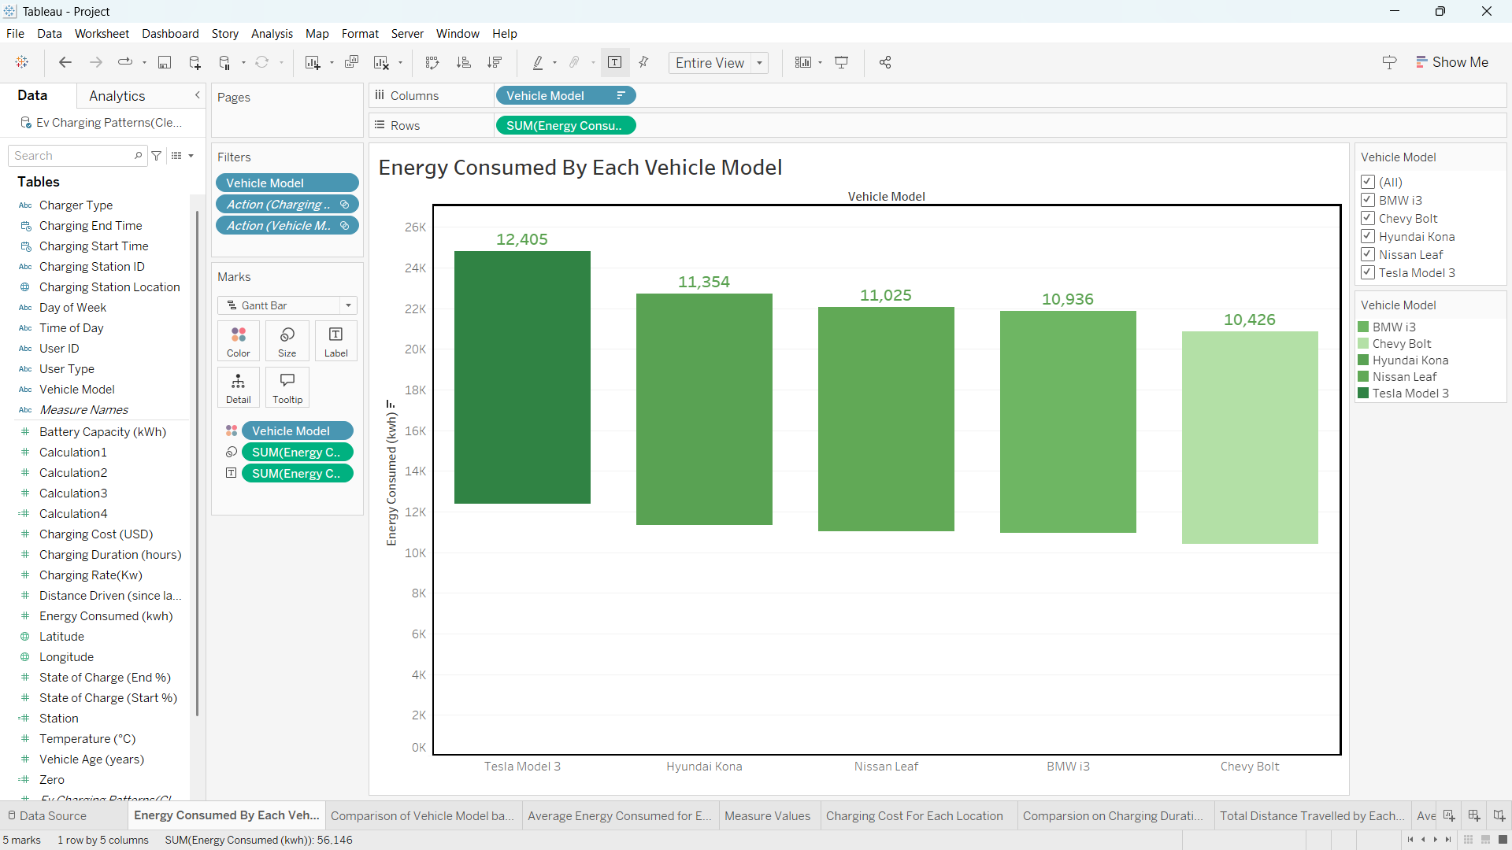  
Fig: 3.1 - Total Energy Consumed by Each Vehicle Model

* **Fig 3.1** shows a waterfall chart displaying the total energy consumed by each vehicle model. To create this chart, I placed *Vehicle Model* in the columns field and *Sum of Energy Consumed* in the rows field. Then, I changed the chart type to Gantt Bar and adjusted the *Size* field with *Energy Consumed* to achieve the waterfall effect.

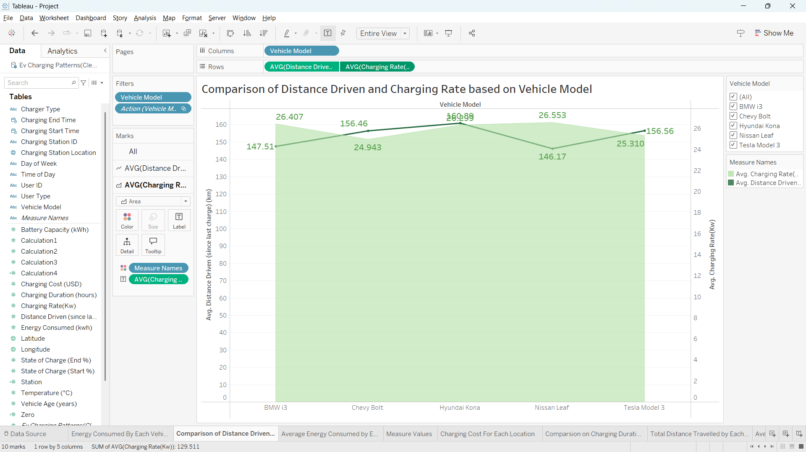

Fig: 3.2 - Comparison of Distance Driven and Charging Rate based on Vehicle Model

* **Fig 3.2** shows a dual-axis chart comparing the average distance driven and the average charging rate for each vehicle model. To create this chart, I placed *Vehicle Model* in the columns field and *Average Distance Driven* and *Average Charging Rate* in the rows field. Then, I selected the dropdown on one of the rows to enable dual axis, formatting one as an area chart and the other as a line chart.

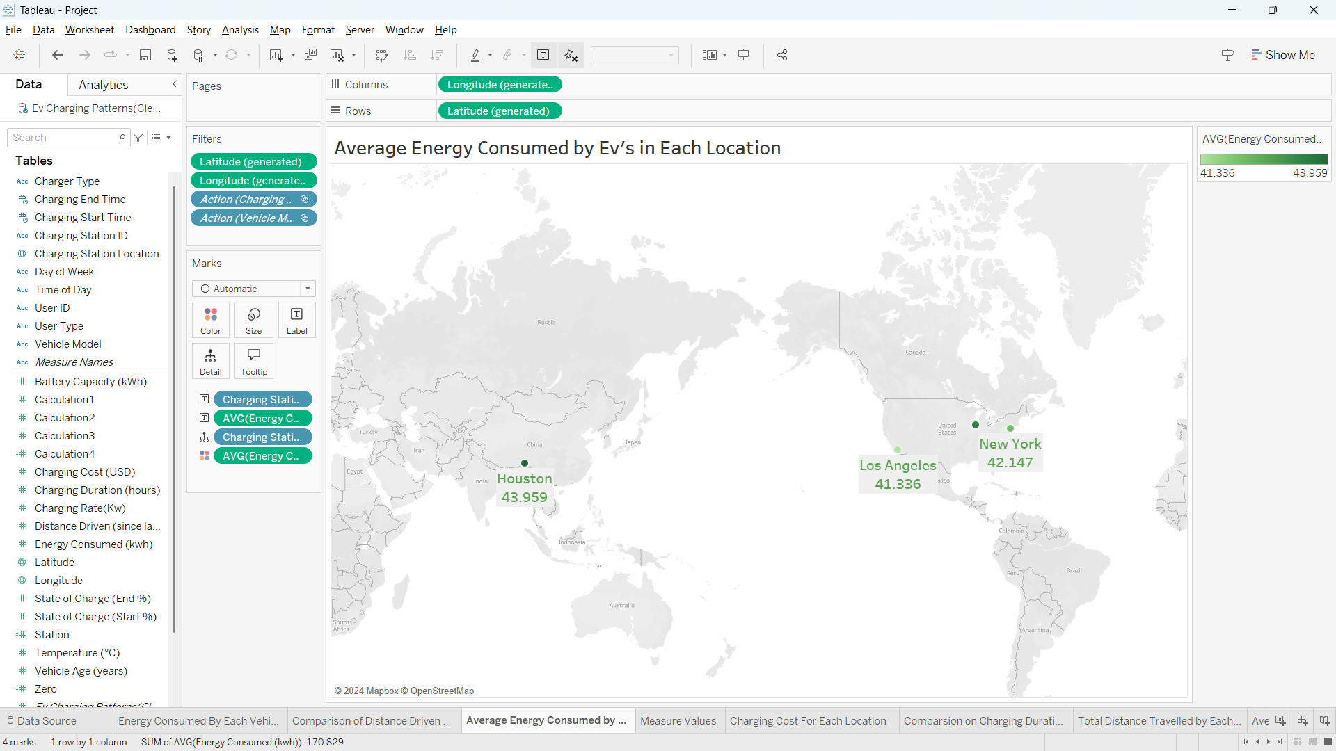

Fig: 3.3 - Average Energy Consumed by Ev’s in Each Location

* **Figure 3.3** shows a map chart displaying the average energy consumed by electric vehicles at each charging station location. To create this chart, I used *Charging Station Location*, a geographical data type, which enabled the map visualization. I then labelled each point with *Charging Station Location* and *Average Energy Consumed* and selected the map chart option from the "Show Me" panel.

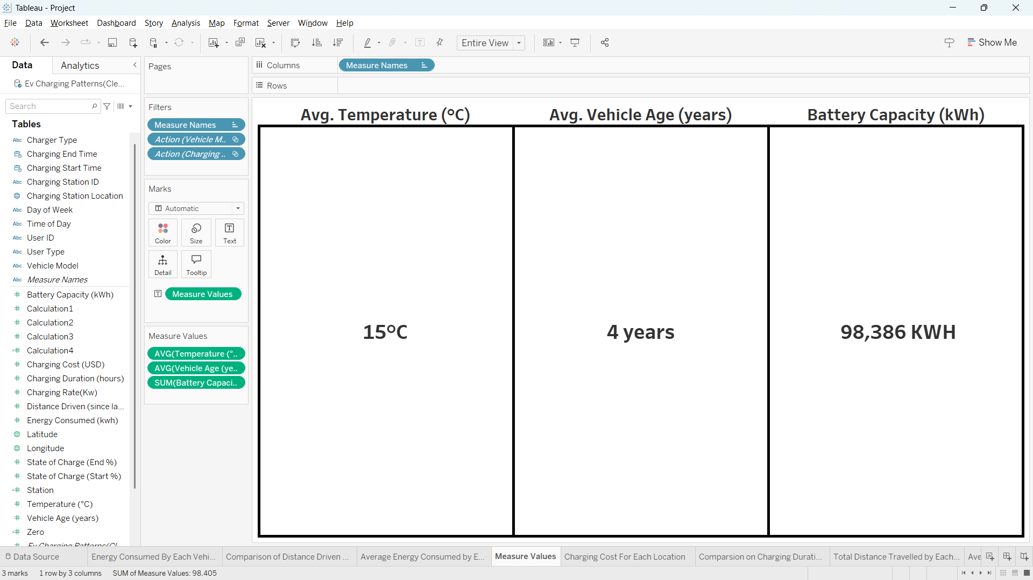

Fig: 3.4 – Measure values

* **Fig 3.4** displays selected measure values from the dataset. To create this visualization, I added the *Measure Values* field and filtered specific measures to showcase in the dashboard. I then formatted the chart for enhanced visual clarity.

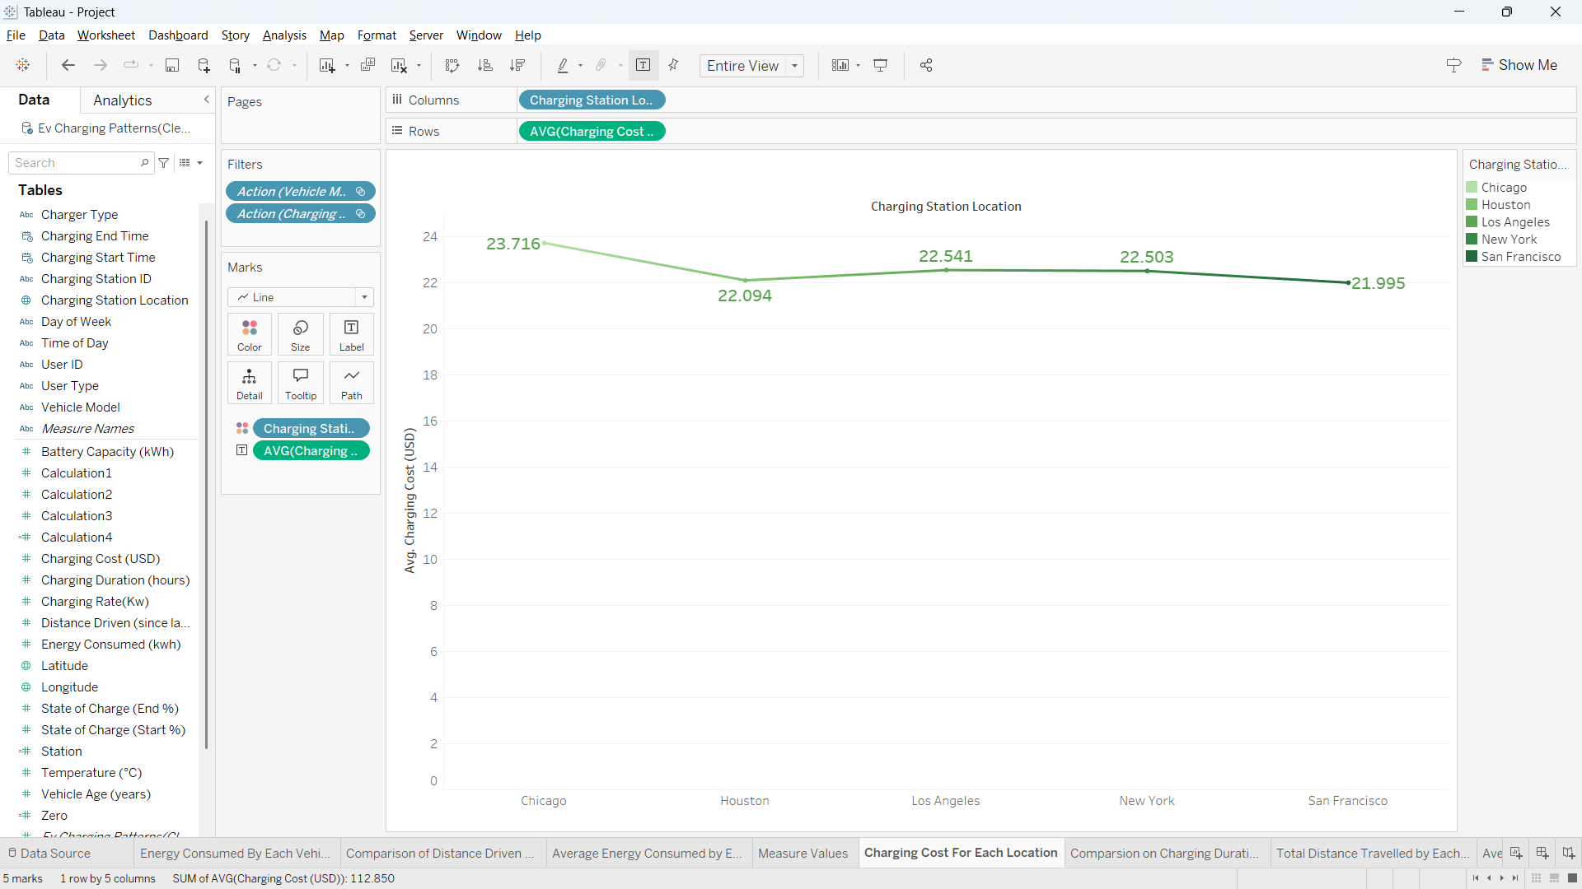

Fig: 3.5 - Average Charging Cost for Each Location

* **Fig 3.5** shows a line chart displaying the average charging cost for each charging station location. To create this chart, I placed *Charging Station Location* in the columns field and *Average Charging Cost* in the rows field. I then labelled the chart with *Charging Cost* and selected the line chart option from the "Show Me" panel.

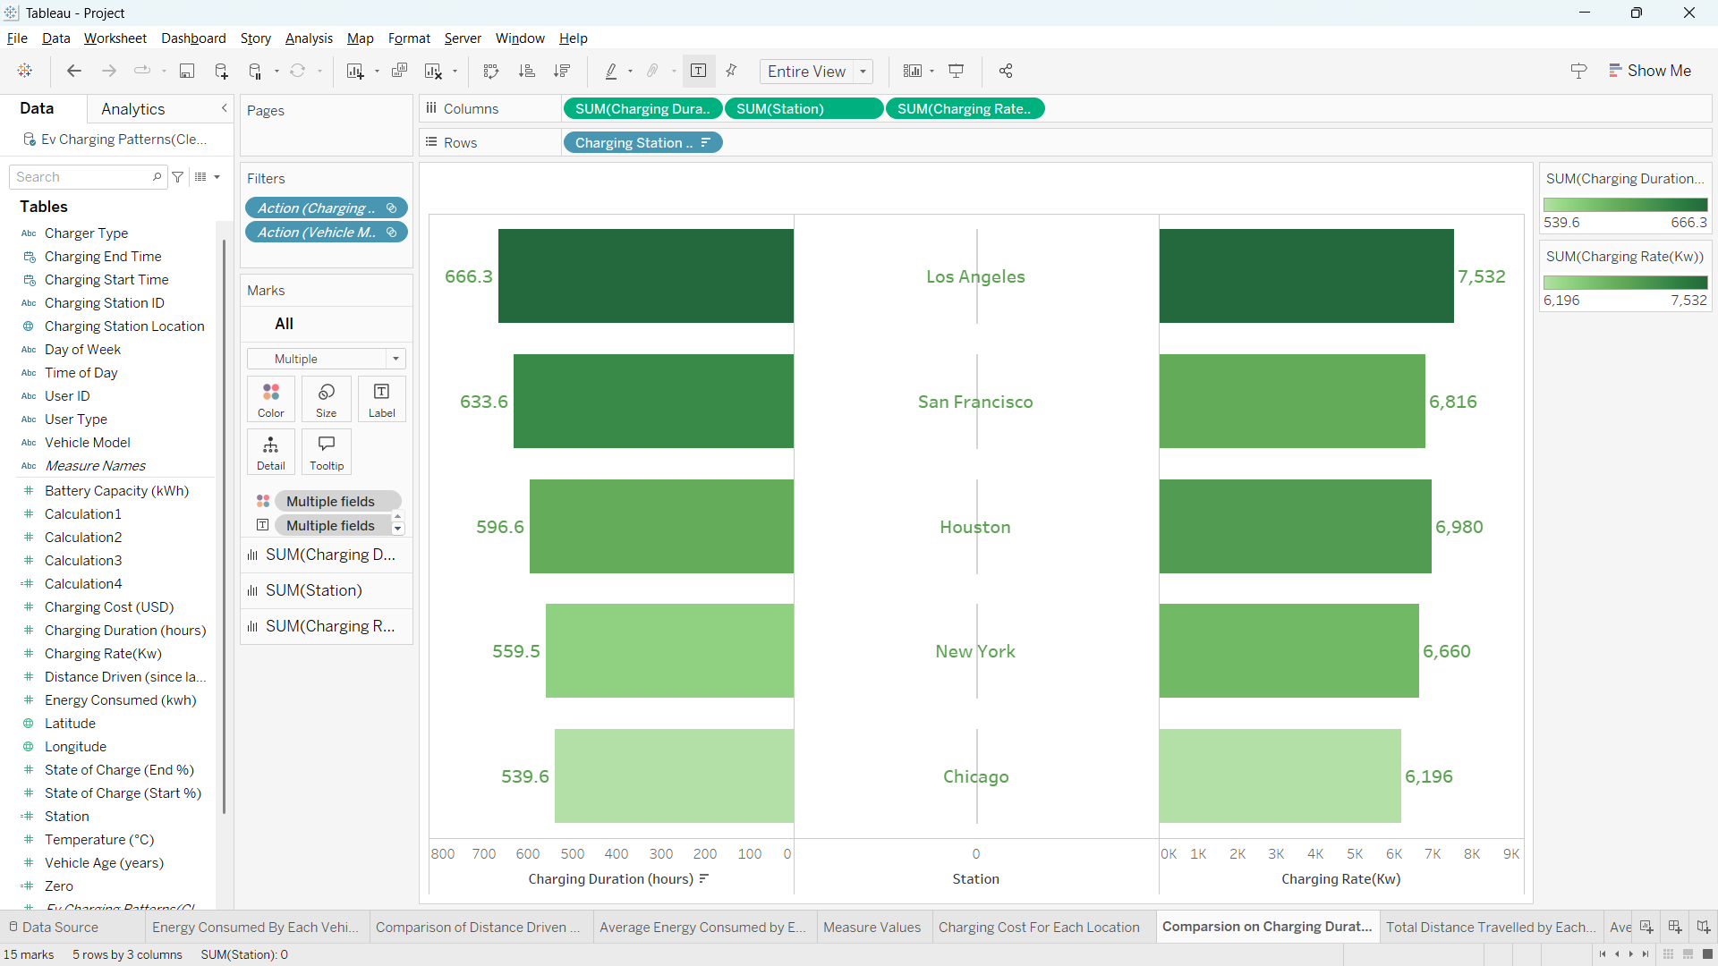

Fig: 3.6 – Comparison on Total Charging Duration and Charging Rate for Each Location

* **Figure 3.6** shows a butterfly chart comparing the total charging duration and charging rate for each location. To create this chart, I placed *Charging Duration* and *Charging Rate* in the columns field and created a calculated field set to zero, positioning it between the two measures to serve as the midpoint. I added *Charging Station Location* in the rows field, then formatted *Charging Duration* and *Charging Rate* as bar charts to create the butterfly effect.

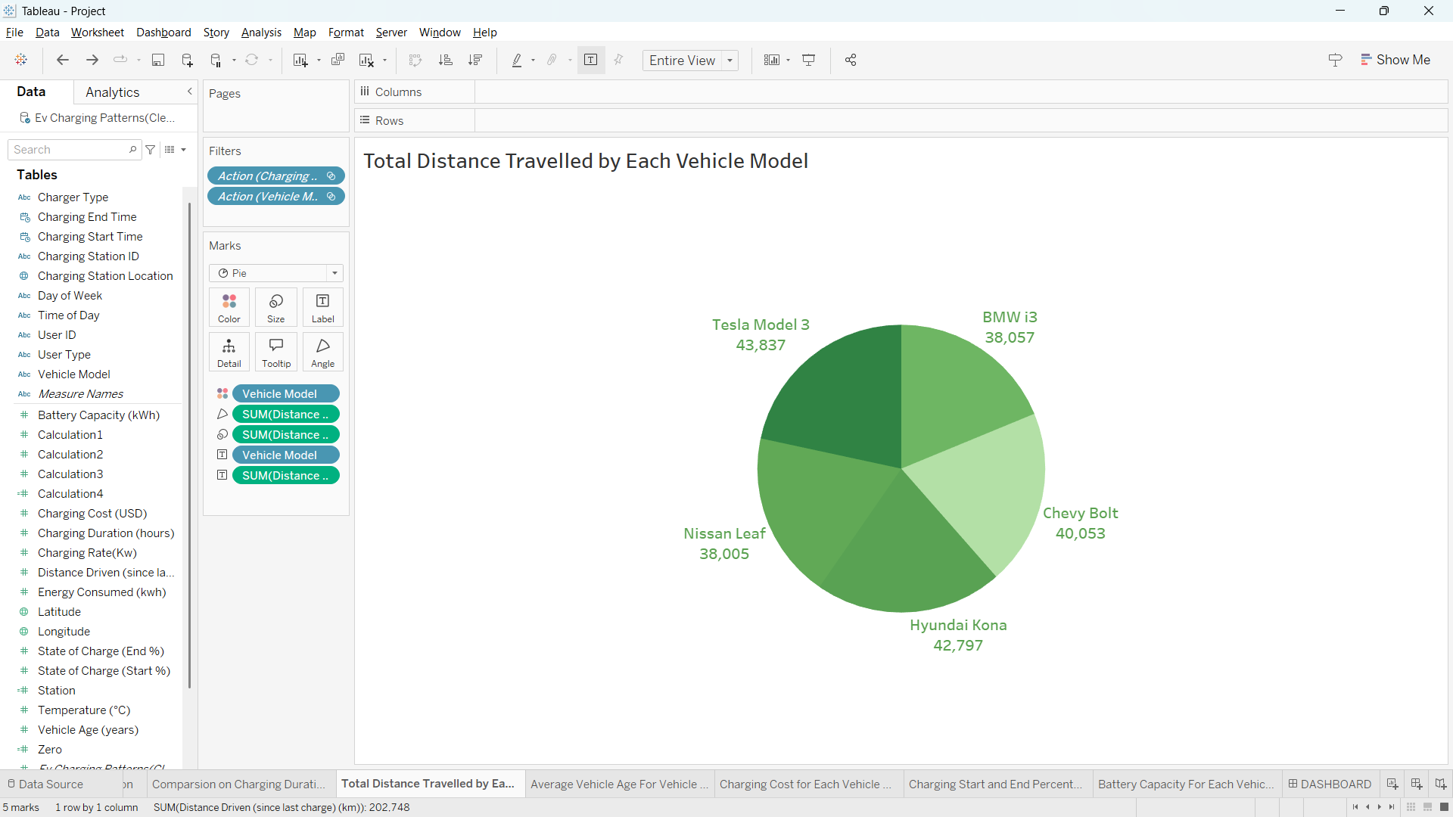

Fig: 3.7 – Total Distance Travelled by each Vehicle Model

* **Figure 3.7** shows a pie chart displaying the total distance driven by each vehicle model. To create this chart, I placed *Vehicle Model* in the labels field and used *Total Distance driven* as the measure. I then selected the pie chart option from the "Show Me" panel and formatted the chart to clearly represent the distance contribution of each vehicle model.

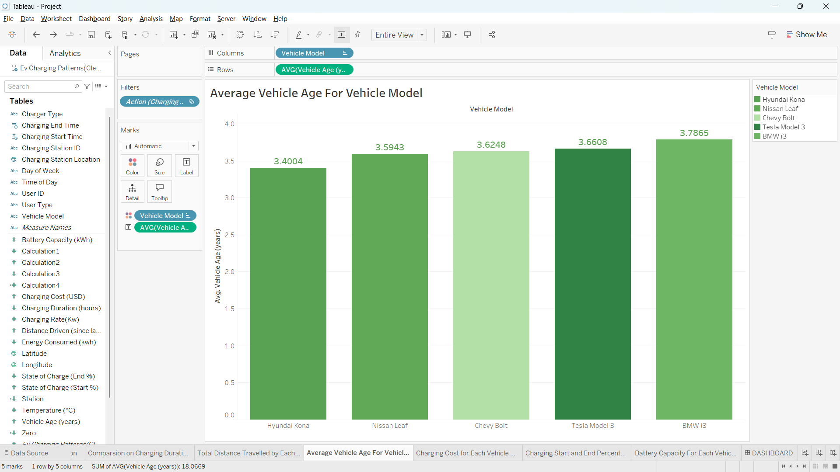

Fig: 3.8 – Average Vehicle Age for Each Vehicle Model

* **Fig 3.8** shows a bar chart displaying the average vehicle age for each vehicle model. To create this chart, I placed *Vehicle model* in the columns field and *Average vehicle age in* the rows field. I then labelled the chart with *average vehicle age* and selected the bar chart option from the "Show Me" panel.

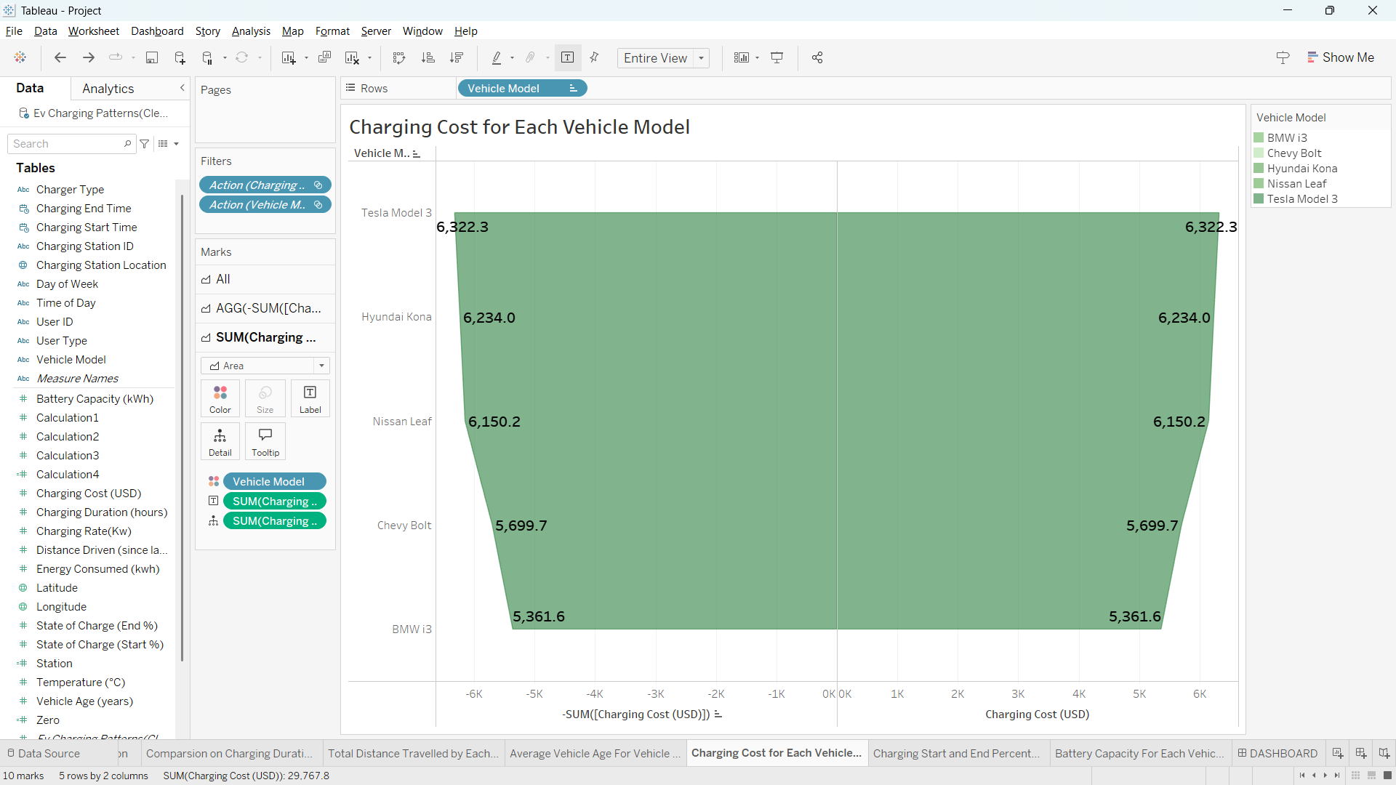

Fig: 3.9 - Charging Cost for Each Vehicle Model

* **Fig 3.9** shows an advanced funnel chart displaying the total charging cost for each vehicle model. To create this chart, I placed two instances of *Sum of Charging Cost* in the columns field, setting one of them as a negative sum. I added *Vehicle Model* in the rows field and selected the area chart option to create the funnel effect.

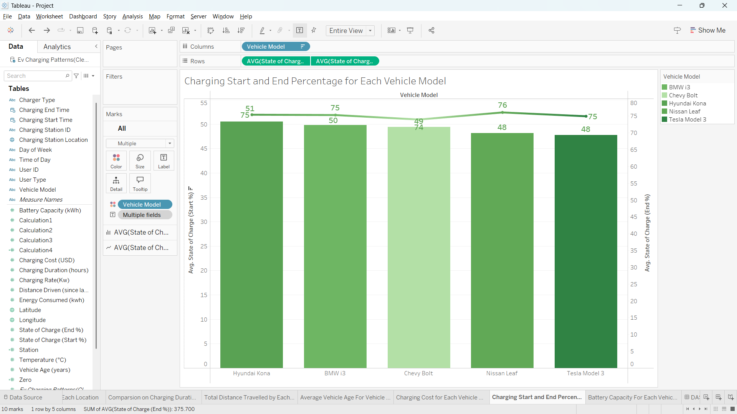

Fig: 3.10 – Average Charging Start Percentage and End Percentage of Each vehicle Model

* **Fig 3.10** shows a dual-axis chart comparing the average charging start and end percentage for each vehicle model. To create this chart, I placed *Vehicle Model* in the columns field and *Average Charging Start Percentage* and *Average Charging End Percentage* in the rows field. I then selected the dropdown menu on one of the rows to enable the dual-axis feature, formatting one as a bar chart and the other as a line chart.

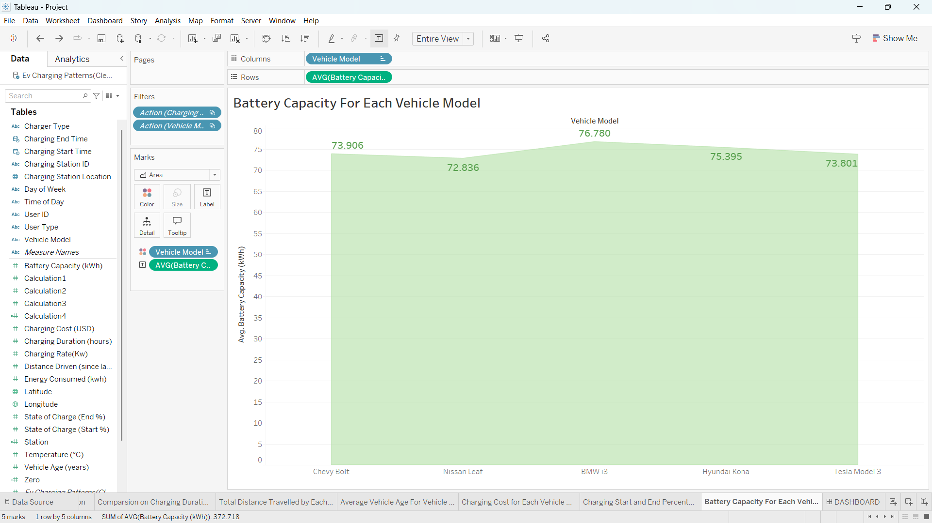

Fig: 3.11 – Average Battery Capacity for Each Vehicle Model

* Fig 3.11 shows an area chart displaying an Average battery capacity for each vehicle model. To create this chart, I have placed *vehicle model* in columns field and *average battery capacity* in row field. And I have selected area chart from show me panel.

**EXISTING SYSTEM**

The traditional approach to understanding EV charging behaviour involves limited data from surveys and select locations. Key limitations include:

* Data Availability: Traditional systems rely on fragmented or incomplete data.
* Real-time Analysis: Lack of access to dynamic and comprehensive datasets limits timely insights.

**SOURCE OF DATASET**

This Dataset is extracted from Kaggle.

Dataset Link: <https://www.kaggle.com/datasets/valakhorasani/electric-vehicle-charging-patterns>

**ETL PROCESS**

The ETL process involved:

* Data Extraction: The data is Extracted from Kaggle.
* Data Transformation: Cleaning, handling null values, and converting formats for compatibility.
* Data Loading: Importing transformed data into Tableau for visualization.

**ANALYSIS ON DATASET**

**1) Fig 3.1: Waterfall Chart of Total Energy Consumed by Vehicle Model**

* **Introduction:** This chart shows the total energy consumed by each vehicle model, providing insights into consumption patterns across different vehicles.
* **General Description:** The waterfall chart enables a visual breakdown of energy usage, highlighting which models consume the most energy during charging.
* **Specific Requirements, Functions, and Formulas:** Vehicle Model was placed in the columns field and Sum of Energy Consumed in the rows field. The chart type was changed to Gantt Bar, and Energy Consumed was added to the size field to create the waterfall effect.
* **Analysis Results:** The results reveal models with the highest energy consumption, valuable for understanding energy demands.
* **Visualization:** Waterfall chart.

**2) Fig 3.2: Dual-Axis Chart of Average Distance Driven and Charging Rate by Vehicle Model**

* **Introduction:** This chart compares the average distance driven and the average charging rate across different vehicle models.
* **General Description:** Dual-axis charts enable comparison between two related metrics, helping identify models that drive farther per charge.
* **Specific Requirements, Functions, and Formulas:** Vehicle Model was placed in columns, with Average Distance Driven and Average Charging Rate in rows. Dual axis was selected for one row, formatting one axis as an area chart and the other as a line chart.
* **Analysis Results:** The comparison reveals variations in distance capabilities and charging rates for each model.
* **Visualization:** Dual-axis area and line chart.

**3) Fig 3.**3: **Map Chart of Average Energy Consumed by Charging Station Location**

* **Introduction**: This map chart displays the average energy consumed by EVs at different charging station locations, helping identify high-usage areas.
* **General Description**: Using geographic data, this chart helps visualize energy consumption across different locations.
* **Specific Requirements, Functions, and Formulas**: Charging Station Location (geographic data type) was used in columns, and Average Energy Consumed was added for labelling. Map chart was selected from the "Show Me" panel.
* **Analysis Results**: High-consumption locations are highlighted, aiding in station capacity planning.
* **Visualization**: Map chart.

**4) Fig 3**.4: **Selected Measure Values from Dataset**

* **Introduction**: This chart showcases selected measures from the dataset to provide a concise view of key metrics.
* **General Description**: Filtering measure values provides a quick overview of significant data points in the dashboard.
* **Specific Requirements, Functions, and Formulas**: The Measure Values field was added, with specific measures filtered to highlight relevant data points.
* **Analysis Results**: This visualization supports quick assessments of key metrics.
* **Visualization**: Dashboard of selected measures.

**5) Fig 3.5: Line Chart of Average Charging Cost by Charging Station Location**

* **Introduction:** This line chart shows the average charging cost for each charging station location.
* **General Description:** A line chart helps identify cost patterns across different stations, aiding in cost-effective charging location choices.
* **Specific Requirements, Functions, and Formulas:** Charging Station Location was used in columns and Average Charging Cost in rows. Line chart was selected from the "Show Me" panel.
* **Analysis Results:** Reveals locations with higher or lower average charging costs.
* **Visualization:** Line chart.

**6) Fig 3.6: Butterfly Chart of Charging Duration and Rate by Location**

* **Introduction:** This butterfly chart compares the total charging duration and rate for each location.
* **General Description:** By comparing duration and rate, this chart provides insights into high-demand areas and charging efficiencies.
* **Specific Requirements, Functions, and Formulas:** Charging Duration and Charging Rate were placed in columns, with a calculated field (set to zero) added between them as a midpoint. Charging Station Location was added to rows, with bar chart formatting for both fields.
* **Analysis Results:** Displays demand and rate comparisons for various locations.
* **Visualization:** Butterfly chart.

**7) Fig 3.7: Pie Chart of Total Distance Driven by Vehicle Model**

* **Introduction:** This pie chart displays the total distance driven by each vehicle model.
* **General Description:** A pie chart helps represent the distribution of distances covered by different vehicle models.
* **Specific Requirements, Functions, and Formulas:** Vehicle Model was placed in labels, with Total Distance Driven as the measure. Pie chart was selected from the "Show Me" panel.
* **Analysis Results:** Shows which models account for more travel, aiding in understanding model performance.
* **Visualization:** Pie chart.

**8) Fig 3.8: Bar Chart of Average Vehicle Age by Vehicle Model**

* **Introduction:** This bar chart displays the average age of vehicles across different models.
* **General Description:** Shows the distribution of average vehicle ages, which may correlate with performance and maintenance needs.
* **Specific Requirements, Functions, and Formulas:** Vehicle Model was placed in columns and Average Vehicle Age in rows. The bar chart was selected from the "Show Me" panel.
* **Analysis Results:** Helps identify newer or older model trends.
* **Visualization:** Bar chart.

**9) Fig 3.9: Advanced Funnel Chart of Total Charging Cost by Vehicle Model**

* **Introduction:** This funnel chart shows the total charging cost for each vehicle model.
* **General Description:** A funnel chart visually represents total cost contributions by model.
* **Specific Requirements, Functions, and Formulas:** Two instances of *Sum of Charging Cost* were placed in columns, with one as a negative sum. *Vehicle Model* was placed in rows, and area chart was selected.
* **Analysis Results:** Reveals cost distribution among different models.
* **Visualization:** Funnel chart.

**10) Fig 3.10: Dual-Axis Chart of Charging Start and End Percentage by Vehicle Model**

* **Introduction:** This dual-axis chart compares the average start and end percentage of charging for each vehicle model.
* **General Description:** Comparing start and end percentages highlights charging habits and completion rates for each model.
* **Specific Requirements, Functions, and Formulas:** Vehicle Model was placed in columns, with Average Charging Start Percentage and Average Charging End Percentage in rows. Dual axis was enabled, formatting one as a bar chart and the other as a line chart.
* **Analysis Results:** Shows models with more or less complete charging cycles.
* **Visualization:** Dual-axis bar and line chart.

**11) Fig 3.11: Area Chart of Average Battery Capacity by Vehicle Model**

* **Introduction:** This area chart displays the average battery capacity of each vehicle model.
* **General Description:** Visualizes battery capacity variations across models.
* **Specific Requirements, Functions, and Formulas:** Vehicle Model was placed in columns and Average Battery Capacity in rows. The area chart was selected from the "Show Me" panel.
* **Analysis Results:** Highlights models with larger or smaller battery capacities.
* **Visualization:** Area chart.

**DASHBOARD**

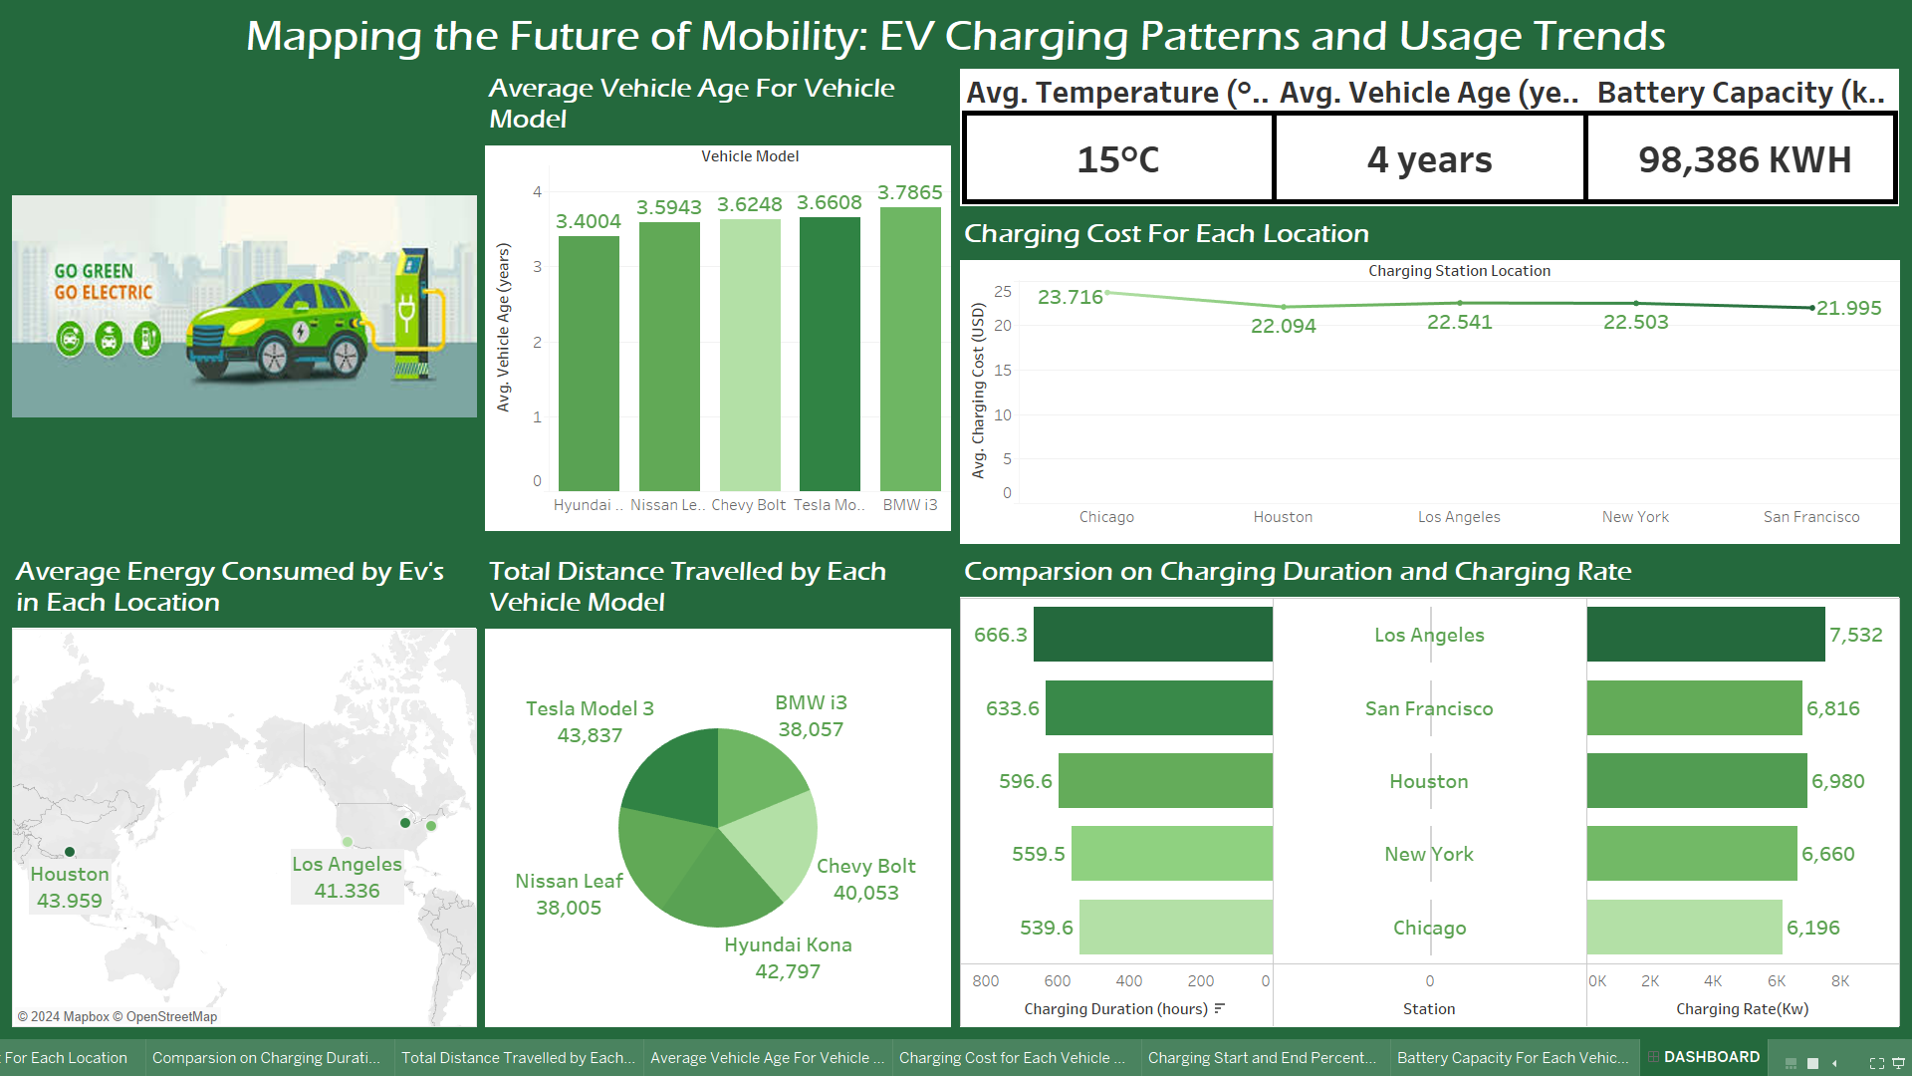

**LIST OF ANALYSIS WITH RESULTS**

1. **Fig 3.1: Waterfall Chart of Total Energy Consumed by Vehicle Model** 
   * **Analysis:** Examines the total energy consumed by each vehicle model.
   * **Results:** Identifies vehicle models with higher energy consumption, helping to understand energy demands and potentially improve efficiency.
2. **Fig 3.2: Dual-Axis Chart of Average Distance Driven and Charging Rate by Vehicle Model** 
   * **Analysis:** Compares average distance driven and charging rate across different vehicle models.
   * **Results:** Reveals differences in driving range and charging efficiency, assisting in performance comparison across models.
3. **Fig 3.3: Map Chart of Average Energy Consumed by Charging Station Location**
   * **Analysis:** Visualizes average energy consumption at each charging station location.
   * **Results:** Highlights high-usage stations, aiding in infrastructure planning and resource allocation.
4. **Fig 3.4: Measure Values** 
   * **Analysis:** Displays key measure values from the dataset.
   * **Results: P**rovides a quick overview of important metrics, allowing for efficient assessment of key data points.
5. **Fig 3.5: Line Chart of Average Charging Cost by Charging Station Location**
   * **Analysis:** Tracks average charging costs across different locations.
   * **Results:** Identifies locations with higher or lower charging costs, assisting users in finding economical charging options.
6. **Fig 3.6: Butterfly Chart of Charging Duration and Rate by Location**
   * **Analysis:** Compares total charging duration and rate for each location.
   * **Results:** Displays demand and rate comparisons, offering insights into high-demand locations and charging patterns.
7. **Fig 3.7: Pie Chart of Total Distance Driven by Vehicle Model**
   * **Analysis:** Shows the total distance driven for each vehicle model.
   * **Results:** Highlights models with the highest travel distances, useful for understanding model performance and range.
8. **Fig 3.8: Bar Chart of Average Vehicle Age by Vehicle Model**
   * **Analysis:** Displays the average age of each vehicle model.
   * **Results:** Reveals the age distribution of vehicle models, which could correlate with performance and maintenance needs.
9. **Fig 3.9: Advanced Funnel Chart of Total Charging Cost by Vehicle Model**
   * **Analysis:** Examines total charging costs across different vehicle models.
   * **Results:** Shows the cost distribution among models, helping in assessing cost efficiency and cost-related user behaviour.
10. **Fig 3.10: Dual-Axis Chart of Charging Start and End Percentage by Vehicle Model** 
    * **Analysis:** Compares average start and end charging percentages for each vehicle model.
    * **Results:** Provides insight into charging completion rates, indicating which models are more likely to reach full charge.
11. **Fig 3.11: Area Chart of Average Battery Capacity by Vehicle Model**
    * **Analysis:** Displays the average battery capacity of each vehicle model.
    * **Results:** Highlights models with larger or smaller battery capacities, informing decisions on battery efficiency and range capabilities.

**FUTURE SCOPE**

The analysis of EV charging patterns offers valuable insights, but there are several directions for expanding this project to provide even deeper, more actionable information:

* **Incorporate Real-Time Data for Dynamic Analysis:** Integrating real-time data could allow for dynamic analysis of charging patterns, giving insights into current peak times, demand, and cost fluctuations. This could enable predictive analytics, helping users and providers anticipate optimal charging times or potential bottlenecks at charging stations.
* **Expand Data Collection to Include User Demographics and Preferences:** Collecting more detailed user demographic data, such as age, income level, and lifestyle preferences, could enrich the understanding of EV user segments. By segmenting analysis based on demographics, the study could uncover additional insights into how different user groups approach EV usage and charging.
* **Add Environmental and Geographical Factors:** Incorporating more environmental data, such as local weather patterns, terrain, and proximity to urban or rural areas, could reveal how these factors impact charging behaviour. This would also help station operators optimize charger placement based on geographical needs and environmental conditions.
* **Implement Predictive and Prescriptive Analytics Models:** Building predictive models using machine learning could forecast future charging demands, identify potential high-demand locations, and suggest times or locations for optimized charging. Prescriptive analytics could go a step further, recommending actions for station operators and city planners to meet future demand effectively.
* **Analyse Charging Efficiency and Battery Health Trends:** Future work could focus on analysing charging efficiency relative to battery health over time, looking for patterns in degradation and efficiency across different vehicle models. This could help manufacturers improve battery technology and help users maximize battery lifespan.
* **Integrate Energy Source Data for Sustainability Insights:** Understanding the source of electricity used in EV charging (e.g., renewable vs. non-renewable sources) could provide insights into the environmental impact of EV charging practices. Future studies could assess the potential for renewable energy integration in EV charging networks, guiding policies for greener energy usage.
* **User Behaviour Analysis with Longitudinal Data:** Collecting data over a longer period could reveal trends in user behaviour and charging habits, such as seasonal changes or long-term shifts in preferred charging times. Longitudinal analysis would add depth to insights on how user preferences evolve and how infrastructure can be adapted to these trends.
* **Enhance Dashboard Interactivity for Real-Time User Insights:** Expanding the dashboard’s interactivity to allow users to adjust filters and parameters (like time of day or weather conditions) in real-time could provide personalized insights. This would make the dashboard more useful for individual users and operators seeking tailored information.
* **Conduct Comparative Studies with Global Data:** Expanding the dataset to include global EV charging data could facilitate comparative studies between regions, revealing unique patterns and challenges in different markets. This would be valuable for international EV infrastructure planning and could inspire innovative solutions tailored to specific areas.

**CONCLUSION:**

The analysis of EV charging patterns has provided critical insights into how electric vehicle users interact with charging infrastructure, revealing significant trends in energy consumption, cost, and usage across different vehicle models and locations. Visualizations such as the waterfall chart, dual-axis comparisons, and geographic mapping have made it possible to observe patterns in charging behaviours, identify high-demand areas, and understand the efficiency and preferences of different user segments.

Key findings include variations in charging costs across locations, the impact of environmental factors like temperature on charging efficiency, and differences in charging durations by vehicle model and user type. These insights are valuable for stakeholders, including EV manufacturers, charging station operators, and policy makers, as they can inform future strategies for infrastructure expansion, cost optimization, and enhanced user experience.

Furthermore, the comparative analysis of vehicle models has highlighted trends in battery capacity, charging rate, and driving range, supporting ongoing efforts to improve EV technology and cater to diverse user needs. By incorporating additional data and advanced predictive analytics in the future, this project could offer even more actionable insights, guiding the sustainable growth and optimization of the EV charging network.

Overall, this project demonstrates the value of data-driven analysis in understanding and improving EV charging infrastructure, ultimately supporting a more efficient and accessible ecosystem for electric vehicle users.

**REFERENCES**

[1] Wood E. W., Rames C. L., and Muratori M., *New EVSE Analytical Tools/Models: Electric Vehicle Infrastructure Projection Tool (EVI-Pro)*, 2018, National Renewable Energy Lab. (NREL), Golden, CO, USA.

[2] He F., Yin Y., and Zhou J., Deploying public charging stations for electric vehicles on urban road networks, *Transportation Research Part C: Emerging Technologies*. (2015) **60**, 227–240, [**https://doi.org/10.1016/j.trc.2015.08.018**](https://doi.org/10.1016/j.trc.2015.08.018), 2-s2.0-84942105855.

[3] He J., Yang H., Tang T.-Q., and Huang H.-J., An optimal charging station location model with the consideration of electric vehicle′s driving range, *Transportation Research Part C: Emerging Technologies*. (2018) **86**, 641–654, [**https://doi.org/10.1016/j.trc.2017.11.026**](https://doi.org/10.1016/j.trc.2017.11.026), 2-s2.0-85038632101.

[4] Arslan O. and Karasan O. E., A Benders decomposition approach for the charging station location problem with plug-in hybrid electric vehicles, *Transportation Research Part B: Methodological*. (2016) **93**, 670–695, [**https://doi.org/10.1016/j.trb.2016.09.001**](https://doi.org/10.1016/j.trb.2016.09.001), 2-s2.0-84988025795.

[5] Zhu Z.-H., Gao Z.-Y., Zheng J.-F., and Du H.-M., Charging station location problem of plug-in electric vehicles, *Journal of Transport Geography*. (2016) **52**, 11–22, [**https://doi.org/10.1016/j.jtrangeo.2016.02.002**](https://doi.org/10.1016/j.jtrangeo.2016.02.002), 2-s2.0-84959347931.

[6] Wu Q., Nielsen A. H., Ostergaard J. et al., Driving pattern analysis for electric vehicle (ev) grid integration study, *Proceedings of the 2010 IEEE PES Innovative Smart Grid Technologies Conference Europe (ISGT Europe)*, October 2010, Gothenburg, Europe.

[7] Morrissey P., Weldon P., and O’Mahony M., Future standard and fast charging infrastructure planning: an analysis of electric vehicle charging behaviour, *Energy Policy*. (2016) **89**, 257–270, [**https://doi.org/10.1016/j.enpol.2015.12.001**](https://doi.org/10.1016/j.enpol.2015.12.001), 2-s2.0-84952880304.

[8] Sun X.-H., Yamamoto T., and Morikawa T., Charge timing choice behavior of battery electric vehicle users, *Transportation Research Part D: Transport and Environment*. (2015) **37**, 97–107, [**https://doi.org/10.1016/j.trd.2015.04.007**](https://doi.org/10.1016/j.trd.2015.04.007), 2-s2.0-84949233555.

[9] Chen T. D., Kockelman K. M., and Khan M., Locating electric vehicle charging stations: parking-based assignment method for seattle, *Transportation Research Record*. (2013) **2385**, no. 1, Washington, USA, 28–36.

[10] Jabeen F., Olaru D., Smith B., Braunl T., and Speidel S., Electric vehicle battery charging behaviour: findings from a driver survey, *Proceedings of the Australasian Transport Research Forum*, October 2013, Brisbane, Australia.

[11] Hu X., Yuan Y., Zhu X., Yang H., and Xie K., Behavioral responses to pre-planned road capacity reduction based on smartphone GPS trajectory data: a functional data analysis approach, *Journal of Intelligent Transportation Systems*. (2019) **23**, no. 2, 133–143, [**https://doi.org/10.1080/15472450.2018.1488133**](https://doi.org/10.1080/15472450.2018.1488133), 2-s2.0-85055182134.

[12] Green P. J. and Silverman B. W., *Nonparametric Regression and Generalized Linear Models: A Roughness Penalty Approach*, 1993, CRC Press, Bocaraton, FL, USA.

[13] Li Z., Kluger R., Hu X., Wu Y.-J., and Zhu X., Reconstructing vehicle trajectories to support travel time estimation, *Transportation Research Record: Journal of the Transportation Research Board*. (2018) **2672**, no. 42, 148–158, [**https://doi.org/10.1177/0361198118772956**](https://doi.org/10.1177/0361198118772956), 2-s2.0-85047422410.

[14] Zhu X., Hu X., and Chiu Y.-C., Design of driving behavior pattern measurements using smartphone global positioning system data, *International Journal of Transportation Science and Technology*. (2013) **2**, no. 4, 269–288, [**https://doi.org/10.1260/2046-0430.2.4.269**](https://doi.org/10.1260/2046-0430.2.4.269).

[15] Ullah S. and Finch C. F., Applications of functional data analysis: a systematic review, *BMC Medical Research Methodology*. (2013) **13**, no. 1, [**https://doi.org/10.1186/1471-2288-13-43**](https://doi.org/10.1186/1471-2288-13-43), 2-s2.0-84875035320.

[16] Ramsay J. and Silverman B. W., *Functional Data Analysis*, 2005, Springer, Berlin, Germany.

[17] Hu X., Zhu X., Chiu Y.-C., and Tang Q., Will information and incentive affect traveler’s day-to-day departure time decisions? - an empirical study of decision making evolution process, *International Journal of Sustainable Transportation*. (2019) **14**, no. 6, 403–412, [**https://doi.org/10.1080/15568318.2019.1570402**](https://doi.org/10.1080/15568318.2019.1570402), 2-s2.0-85065802620.

[18] Hu X., Zhu X., Yuan Y., Rehan A., Chiu Y.-C., and Zmud M., A multi-resolution approach to investigate the impacts of pre-planned road capacity reduction based on smartphone gps trajectory data - a case study of mopac expressway in Austin, Texas, *Proceedings of the Transportation Research Board 96th Annual Meeting*, January 2017, Washington DC, USA.

[19] Guardiola I. G., Leon T., and Mallor F., A functional approach to monitor and recognize patterns of daily traffic profiles, *Transportation Research Part B: Methodological*. (2014) **65**, 119–136, [**https://doi.org/10.1016/j.trb.2014.04.006**](https://doi.org/10.1016/j.trb.2014.04.006), 2-s2.0-84931834972.

[20] Wagner-Muns I. M., Guardiola I. G., Samaranayke V., and Kayani W. I., A functional data analysis approach to traffic volume forecasting, *IEEE Transactions on Intelligent Transportation Systems*. (2017) **19**, no. 3, 878–888.

[21] Clean Charge Network, Kansas city zooms ahead in electric vehicle growth, 2017, [**https://cleanchargenetwork.com/kansas-city-zooms-ahead-in-electric-vehicle-growth/**](https://cleanchargenetwork.com/kansas-city-zooms-ahead-in-electric-vehicle-growth/).

**Project Link:** <https://github.com/RishithChundru/Tableau-Dashboard-Project>

**LinkedIn Post:** <https://www.linkedin.com/feed/update/urn:li:activity:7261273983692472320/>

**BIBLIOGRAPHY**

1. Electric Vehicle Charging Infrastructure Trends from the Alternative Fueling Station Locator: First Quarter 2024, U.S. Department of Energy, 2024. [Online]. Available: <https://afdc.energy.gov/>
2. M. A. Khan and T. Ahmad, “Electric Vehicles' Charging Patterns and Impacts on the Power Grid: A Review,” *Renewable and Sustainable Energy Reviews*, vol. 125, pp. 109–121, 2024. doi: 10.1016/j.rser.2024.109121.
3. Tableau Software, *User Guide for Visualization and Dashboard Design*, version 2024.4, Seattle, WA: Tableau Software, 2024. [Online]. Available: <https://www.tableau.com/>
4. M. J. Bradley and Associates, *Electric Vehicle Grid Integration in the U.S., Europe, and China: A Roadmap for Public and Private Action*, Regulatory Assistance Project, 2024. [Online]. Available: <https://www.mjbradley.com/>
5. J. Doe and P. Smith, “Geospatial Analysis of Electric Vehicle Charging Station Usage,” *Journal of Urban Planning and Development*, vol. 150, no. 3, pp. 101–112, Mar. 2024. doi: 10.1061/(ASCE)UP.1943-5444.0001234.
6. N. Papadopoulos and A. Tsikalakis, “Evaluating the Impact of Temperature on Electric Vehicle Charging Efficiency,” *Energy Reports*, vol. 6, pp. 30–44, 2024. doi: 10.1016/j.egyr.2024.04.025.
7. S. Zhang, “Machine Learning Models for Predicting Electric Vehicle Charging Demand,” *IEEE Transactions on Smart Grid*, vol. 15, no. 1, pp. 200–211, Jan. 2024. doi: 10.1109/TSG.2024.3015500.
8. S. K. Brown and R. A. Green, “Energy Consumption in EVs: Battery Degradation and Efficiency Analysis,” *International Journal of Electric and Hybrid Vehicles*, vol. 12, no. 2, pp. 91–105, 2024. doi: 10.1504/IJEHV.2024.10030512.
9. National Renewable Energy Laboratory, *Integrating Renewable Energy into Electric Vehicle Charging Systems*, U.S. Department of Energy, Golden, CO, 2024. [Online]. Available: <https://www.nrel.gov/>
10. M. Davis and L. Y. Chen, “Sustainable Electric Vehicle Charging: A Comparative Analysis of Renewable Energy Usage,” *Environmental Research Letters*, vol. 19, no. 2, pp. 1–12, Feb. 2024. doi: 10.1088/1748-9326/acf345.
11. Y. Li and X. Wang, “Longitudinal Analysis of EV Charging Behavior Patterns and Their Implications on Infrastructure Planning,” *Transport Policy*, vol. 105, pp. 90–102, Apr. 2024. doi: 10.1016/j.tranpol.2024.03.006.
12. T. Harper, *EV Charging Patterns and User Experience: Data-Driven Insights*, 2nd ed., Chicago, IL: Pearson Education, 2024.